Reservation and Departure Control systems connection to The Integrated Government Information System of Transport Security (IGIS TS) via Aviation Service Platform.

This document describes the process for being compliant with the government’s requirements for provision of Advance Passenger Information (APIS) and Passenger Name Record (PNR) data (PAXLST messages in EDIFACT format) in Type B envelope to The Integrated Government Information System of Transport Security (IGIS TS) via Aviation Service Platform (ASP) Information System. The Ministry of Transport of the Russian Federation has mandated
FSUE “ZaschitaInfoTrans” to provide airlines with secure electronic data interchange in formats familiar to airlines, to comply with national APIS PNR data provision requirements via ASP. Note that the provision of PNR data will become mandatory after changers in Order № 243 will come into force later this year.
Since APIS and PNR messages are generated by reservation (RES) and registration (DCS) systems, it will be necessary to establish communication channel between such a system and ASP.

Communication links to RES and DCS systems.
IGIS TS communication link via ASP supports the following connectivity options for the Push method:

• Airline MQ Hub server to ASP MQ client connection.
Message queue MQ is a software-engineering component that implements guaranteed delivery messaging infrastructure.
• Airline to ASP server-to-server connection.
The Simple Mail Transfer Protocol (SMTP) is worldwide used Internet standard communication protocol for electronic mail transmission over TCP/IP networks.
• Airline to ASP connection using S3 object storage.
S3 (Simple Storage Service) is a secure Internet service for storing and exchanging digital data using a special type of resource, S3 connector.

All communication links are widely used in airtransport industry and are similar to those used in the SITA and ARINC networks.

In addition to PNR and APIS messaging, this connection can be used to exchange Type B messages with BHS, LDCS, and other airport information systems. Also, airlines can use ASP secure communication channels to provide their host DCS operation. Connection details will be defined with each airline.
FSUE “ZaschitaInfoTrans” will provide Configuration form to airlines.
This is achieved using a network connection between the airline’s system(s) and the ASP, as shown below. For security reasons, data transmission to the gateway with the ASP will be carried out over VPN connection. Connection from ASP the gateway to IGIS TS is provided using a set of network security protocols that comply with Russian legislation and standards, using equipment that cannot be exported.
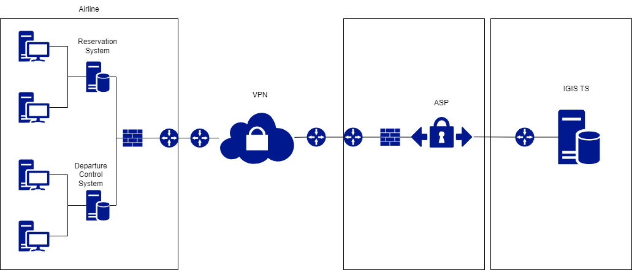
The process of interaction with airlines is grouped into the following main stages:

Stage 1 – Contact.
• The first kick-off meeting between the airline and FSUE ZaschitaInfoTrans.

Stage 2 – Development.
• Agree on the method of data transmission.
• Ensure there is a successful connection at a Network level (Testing and Production Environments) between Airline hosts and ASP.

Stage 3 – Testing.
• Network connection test.
• Test data samples in accordance with Government requirements.
• Connection and data elements quality sign off by IGIS TS.

Stage 4 – Cutover.
• Agree on a Move to Production date between FSUE ZaschitaInfoTrans and airline.
• Move to Production and monitor traffic reception.

